Understanding Fuzzy Logic and Its Role in Stock Prediction

1. Introduction to Fuzzy Logic

Fuzzy Logic is a mathematical framework for dealing with uncertainty and imprecise data. Unlike traditional binary logic, which classifies inputs as either True (1) or False (0), fuzzy logic allows for degrees of truth, enabling systems to make more human-like decisions.

2. How Fuzzy Logic Works

Fuzzy logic consists of the following components:

1. **Fuzzification**: Converts numerical input data into fuzzy sets using membership functions.
2. **Inference Engine**: Applies rules (IF-THEN statements) to process fuzzy inputs and derive conclusions.
3. **Defuzzification**: Converts the fuzzy output into a precise numerical value for decision-making.

3. Benefits of Fuzzy Logic in Stock Prediction

* **Handles Market Uncertainty**: Unlike rigid algorithms, fuzzy logic adapts to varying market conditions.
* **Incorporates Expert Knowledge**: Allows the use of qualitative insights (e.g., "the market is slightly bullish").
* **Smooth Decision-Making**: Avoids abrupt jumps in predictions, providing gradual trend identification.

4. Example: Predicting a Stock Price Using Fuzzy Logic

**a) Defining Inputs**

Consider an Indian stock (e.g., Reliance Industries - RELIANCE) where the key factors influencing its price prediction include:

* **Market Sentiment (Positive, Neutral, Negative)**
* **Trading Volume (Low, Medium, High)**
* **Recent Price Trends (Upward, Stable, Downward)**

**b) Fuzzification**

* If Market Sentiment is Positive and Trading Volume is High, the stock has a **High Buy Potential**.
* If Market Sentiment is Neutral and Trading Volume is Medium, the stock has a **Moderate Buy Potential**.
* If Market Sentiment is Negative and Price Trend is Downward, the stock has a **High Sell Potential**.

**c) Rule-Based System**

| **Market Sentiment** | **Trading Volume** | **Price Trend** | **Prediction** |
| --- | --- | --- | --- |
| Positive | High | Upward | Strong Buy |
| Neutral | Medium | Stable | Hold |
| Negative | Low | Downward | Strong Sell |

**d) Defuzzification**

* Using weighted average methods, the final decision (e.g., Buy, Hold, Sell) is computed based on fuzzy rules.

5. Visual Representation

A graph plotting fuzzy membership functions could illustrate the gradual transitions between buy, hold, and sell zones, providing a more intuitive trading strategy compared to strict thresholds.

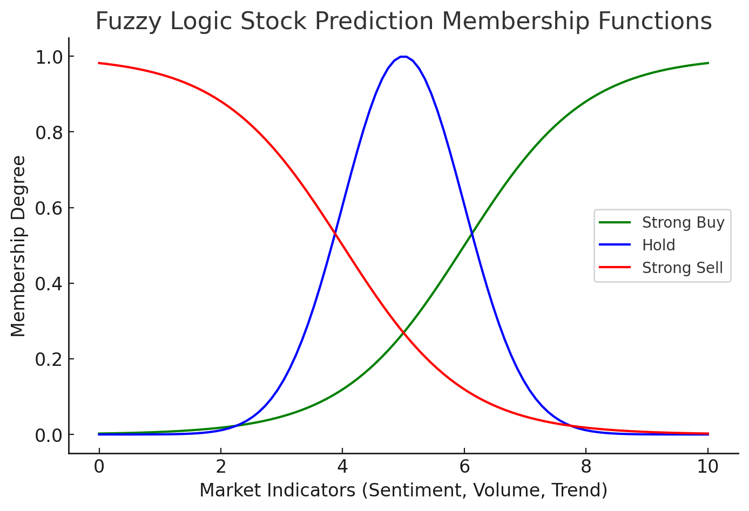

6. Conclusion

Fuzzy logic provides a robust method for stock market prediction, allowing for flexible and adaptive decision-making. By incorporating fuzzy rules, Hand&Brain can refine its predictive model, offering traders better insights while handling market uncertainties effectively.